Experiment 7
Create a XML file to store student information like name, enrollment number, mobile number and email id.
CODE:
XML code (Students.xml) :
<?xml version="1.0" encoding="UTF-8"?>

<?xml-stylesheet type="text/xsl" href="students.xslt"?>

<students>
<student>
<enroll>301</enroll>
<name>Karan Mehta</name>
<mobile>9012345678</mobile>
<email>karan@gmail.com</email>
</student>

<student>
<enroll>302</enroll>
<name>Aisha Khan</name>
<mobile>9123456789</mobile>
<email>aisha@gmail.com</email>
</student>

<student>
<enroll>303</enroll>
<name>Vikas Gupta</name>
<mobile>9234567890</mobile>
<email>vikas@gmail.com</email>
</student>

<student>
<enroll>304</enroll>
<name>Neha Sharma</name>
<mobile>9345678901</mobile>
<email>neha@gmail.com</email>
</student>

<student>
<enroll>305</enroll>
<name>Rohit Verma</name>
<mobile>9456789012</mobile>
<email>rohit@gmail.com</email>
</student>

<student>
<enroll>306</enroll>
<name>Pooja Singh</name>
<mobile>9567890123</mobile>
<email>pooja@gmail.com</email>
</student>

<student>
<enroll>307</enroll>
<name>Amit Joshi</name>
<mobile>9678901234</mobile>
<email>amit@gmail.com</email>
</student>

<student>
<enroll>308</enroll>
<name>Sneha Patel</name>
<mobile>9789012345</mobile>
<email>sneha@gmail.com</email>
</student>

<student>
<enroll>309</enroll>
<name>Arjun Kumar</name>
<mobile>9890123456</mobile>
<email>arjun@gmail.com</email>
</student>

<student>
<enroll>310</enroll>
<name>Meera Nair</name>
<mobile>9901234567</mobile>
<email>meera@gmail.com</email>
</student>
</students>
XSLT code (students.xslt) :
<?xml version="1.0" encoding="UTF-8"?>

<xsl:stylesheet version="1.0"
xmlns:xsl="http://www.w3.org/1999/XSL/Transform">

<xsl:template match="/">

<html>
<head>
<title>Student Table</title>
<link rel="stylesheet" type="text/css" href="style.css"/>
</head>

<body>
<h2>Student Information Table</h2>

<table>
<tr>
<th>Enroll No</th>
<th>Name</th>
<th>Mobile</th>
<th>Email</th>
</tr>

<!-- Sorting -->
<xsl:for-each select="students/student">
<xsl:sort select="name" order="ascending"/>

<tr>
<td><xsl:value-of select="enroll"/></td>
<td><xsl:value-of select="name"/></td>
<td><xsl:value-of select="mobile"/></td>
<td><xsl:value-of select="email"/></td>
</tr>
</xsl:for-each>

</table>
</body>
</html>

</xsl:template>

</xsl:stylesheet>
CSS code (style.css) :
body {
font-family: Arial;
background-color: #f0f8ff;
}

h2 {
text-align: center;
color: #2c3e50;
}

table {
border-collapse: collapse;
width: 70%;
margin: 20px auto;
background: white;
box-shadow: 0px 0px 8px rgba(0,0,0,0.2);
}

th {
background-color: #3498db;
color: white;
padding: 12px;
}

td {
border: 1px solid #ddd;
padding: 10px;
text-align: center;
}

tr:nth-child(even) {
background-color: #f2f2f2;
}

tr:hover {
background-color: #d6eaf8;
}
OUTPUT:
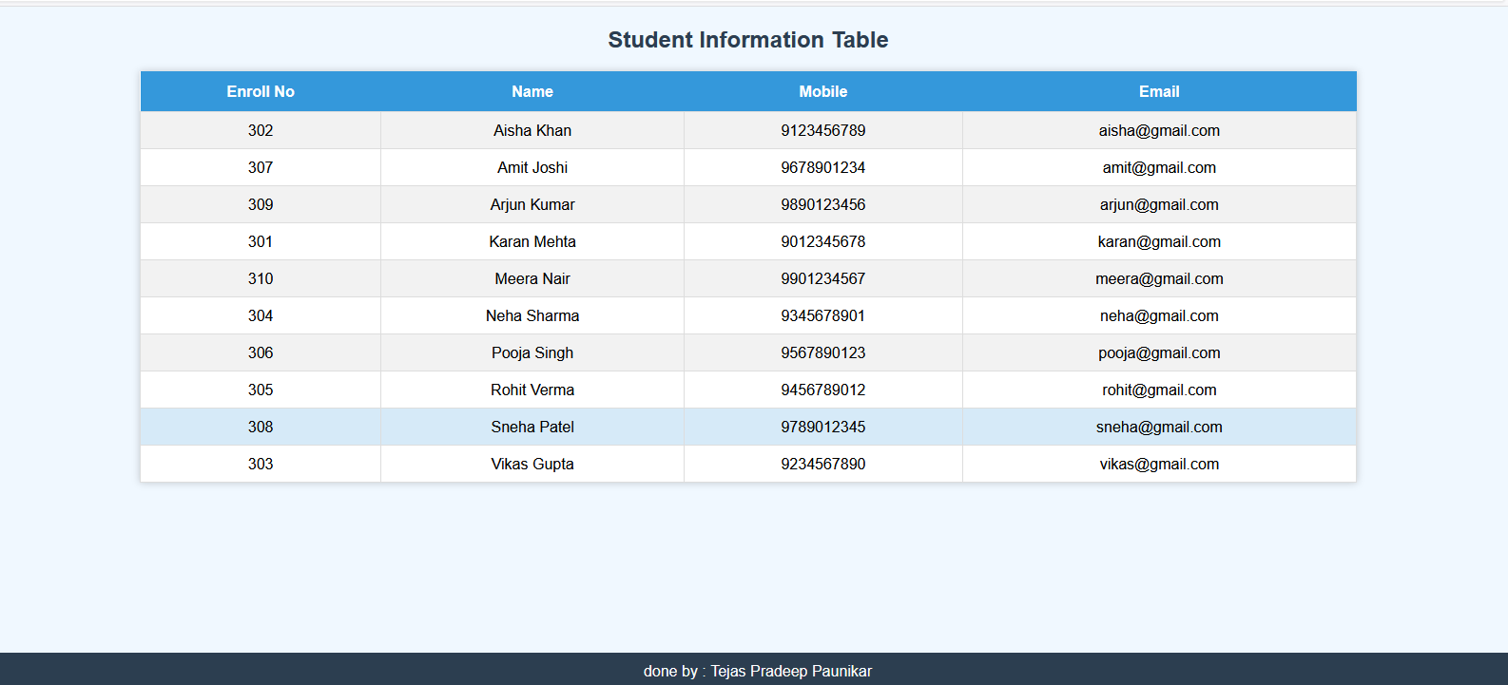
By Sameer Diwakar, Enrolment no:02396302723

